DIGITAL MARKETING

Assignment 2- Create a facebook page and posting social media

Poster

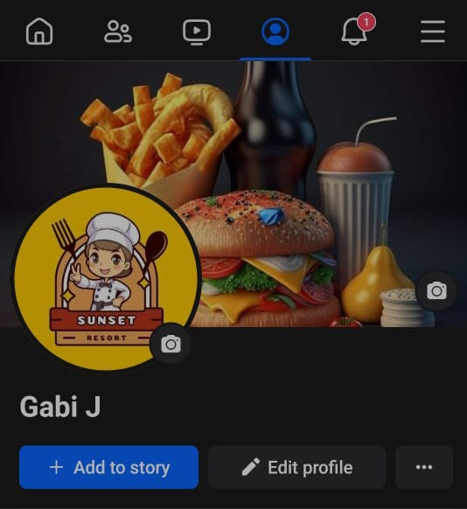

Figure: facebook profile



Figure: Social media poster

Facebook post link:

<https://m.facebook.com/story.php?story_fbid=pfbid0uD6W8ZHVXn9ETrjkY1dKD28ooqCr9JASgPngD3ZMZoJPkDKbVDejRUa41b4AMB1Hl&id=61552752329085&mibextid=9R9pXO>